

**OPERATING SYSTEM(SIT3109)**

**Lab Assessment**

**FALL 2023**

|  |  |  |  |
| --- | --- | --- | --- |
| **Course Title** | **OPERATING SYSTEM** | **Code** | **SIT3109** |
| **Semester** | **Fall 2023** | **Faculty** | **Ms. Bismi Azeez** |
| **Duration** | **Week 13** | **Date** | **07-Dec-2023** |
| **Assessment** | **Lab Assessment 1** | **Weightage**  **(%)** | **20** |
| **Course Learning Outcomes Covered** | | | |
| **CLO4** | **Evaluate the execution of operating system programs and its security aspects.**  **20 Marks (QF Emirates S1 (4), S2 (4), AR1(4), AR4(4), SD3(4)** | | |

|  |  |  |  |
| --- | --- | --- | --- |
| **Question** | **CLO Covered** | **Max Marks** | **Marks Obtained** |
| **Q1,Q2, Q3** | **CLO4** | **12 Marks QF Emirates AR1(4), AR4(4), SD3(4)** |  |
| **Q4** | **CLO4** | **8 Marks (QF Emirates S2 (4), S1 (4))** |  |
| **Total Marks** | | **20** |  |
| **Instructor Sign** | | **Ms. Bismi Azeez** | |
| **Student ID** | |  | |
| **Student Name** | |  | |
| **Comments** | | | |
|  | | | |

**Instructions to Students:**

* Submission is no later than Friday, 10/December/2023 @ 23:59.
* You are required to submit your soft copy of your java code/ os commands and output via LMS.
* Email submission will not be considered.

**Questions:**

1. Consider the set of 4 processes whose arrival time and burst time are given below.

Write and execute a Java program and calculate the average waiting time and average turnaround time if the CPU scheduling policy is FCFS.

**4 Marks QF Emirates AR1(4)**

|  |  |  |
| --- | --- | --- |
| **Process Id** | **Arrival time** | **Burst time** |
| P1 | 0 | 2 |
| P2 | 1 | 2 |
| P3 | 5 | 3 |
| P4 | 6 | 4 |

1. Consider the set of 4 processes whose burst time are given below-

Write and execute a Java program and calculate the average waiting time and average turnaround time if the CPU scheduling policy is SJF non-preemptive. **4 Marks QF Emirates AR4(4)**

|  |  |  |
| --- | --- | --- |
| **Process Id** | **Arrival time** | **Burst time** |
| P1 | 1 | 3 |
| P2 | 2 | 4 |
| P3 | 1 | 2 |
| P4 | 4 | 4 |

1. Consider the set of 4 processes whose arrival time is 0 and burst time is given below-

If the CPU scheduling policy is Round Robin with time quantum = 5 unit. Write a program to calculate the average waiting time and average turnaround time. **4 Marks QF Emirates SD3(4)**

|  |  |
| --- | --- |
| **Process Id** | **Burst time** |
| P1 | 21 |
| P2 | 3 |
| P3 | 6 |
| P4 | 2 |

1. Write and execute the command for the following:
2. Create a folder as ‘myfolder’ and create a file as `example.txt`in ‘myfolder’, write the command to print the last 10 lines of the file.

**mkdir myfolder**

**cd myfolder**

**touch example.txt**

**tail -n 10 example.txt**

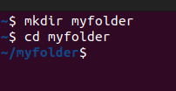

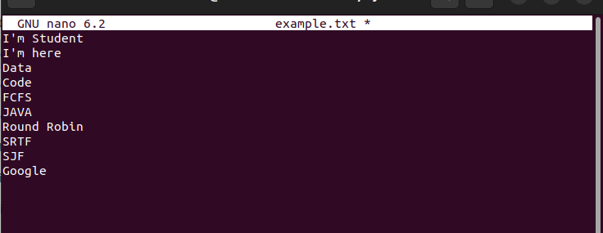

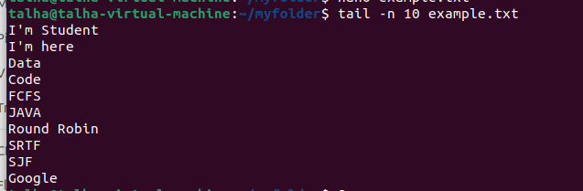

1. Write the command to find the file present in home directory of a user whose precise location is unknown

**cd ~**

**touch finding.txt**

**find ~ -name finding.txt**

**General: find ~ -name filename**

**Filename can be a.txt, a.html, bb.txt etc**

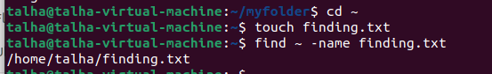

1. Write the command to check the permission of ‘example.txt’

**ls -l example.txt**



1. Write the command to check the groups of the current user.

**groups**



1. Write the command to change the permission of ‘example.txt’ (Give all permission to user, read & write permission to group and read only permission to others)

**chmod 764 example.txt**

**7: The user gets read (4), write (2), and execute (1) permissions hence doing a total of 7 ==4+2+1.**

**6: The group gets read (4) and write (2) permissions, so there is a total of 6 == 4+2.**

**4: Others get read (4) permission 4==4.**



**8 Marks (QF Emirates S2 (4), S1 (4))**